**B. Normal random numbers**

**1. Code**

# set working directory to Lab 03

setwd("C:/Users/jordan/Google Drive/Courses Spring 2018/STAT 350/STAT 350 Labs/Lab 03")

# set up ggplot2 for plotting

library(ggplot2)

# close any open plots

graphics.off()

### PART B ###

# generate 10 observations from a normal distribution with

# mean = 9 and standard deviation = 4.5

NormalB <- rnorm(10,mean=9,sd=4.5)

write.table(NormalB, "NormalB.txt", sep="\t")

Normal <- NormalB

# create histogram

windows()

title <- "Normal Distribution, Part B1"

ggplot(data.frame(Normal=Normal),aes(x=Normal))+

geom_histogram(aes(y=..density..),bins=sqrt(length(Normal))+2,

fill="grey",col="black")+

geom_density(col="red",lwd=1)+

stat_function(fun=dnorm,args=list(mean=mean(Normal),sd=sd(Normal)),

col="blue",lwd=1)+

ggtitle(title)+

xlab("Data")+

ylab("Proportion")

# create normal probability plot, AKA QQ plot

windows()

title <- "Normal Distribution, Part B2"

ggplot(data.frame(Normal=Normal),aes(sample=Normal))+

stat_qq()+

geom_abline(slope=sd(Normal),intercept=mean(Normal))+

ggtitle(title)+

xlab("Theoretical")+

ylab("Sample")

**2.** **Histogram**

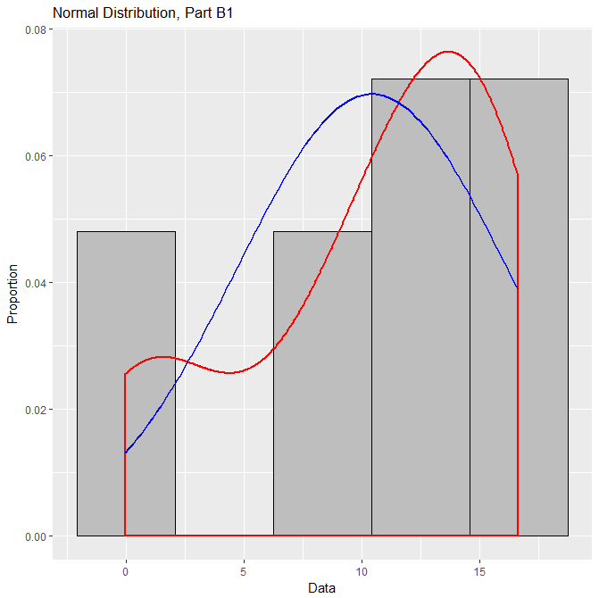

The shape of this histogram does not very closely resemble a normal density curve. The tails are rather short and it appears to be left-skewed.

**3. Normal Probability Plot**

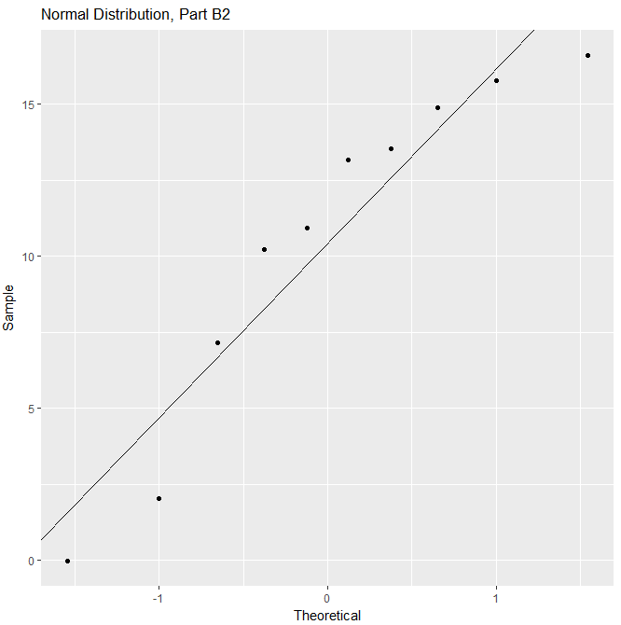

This plot suggests that this data set deviates quite a bit from normality. Specifically, we can see the leftmost two data points are rather far below the line of normality, while the middle data points are notably above the line, and finally the rightmost data point is quite far from normality.

**C. Normal random numbers**

**1. Code**

### PART C ###

# generate 100 observations from a normal distribution with

# mean = 9 and standard deviation = 4.5

NormalC <- rnorm(100,mean=9,sd=4.5)

write.table(NormalC, "NormalC.txt", sep="\t")

Normal <- NormalC

# create histogram

windows()

title <- "Normal Distribution, Part C1"

ggplot(data.frame(Normal=Normal),aes(x=Normal))+

geom_histogram(aes(y=..density..),bins=sqrt(length(Normal))+2,

fill="grey",col="black")+

geom_density(col="red",lwd=1)+

stat_function(fun=dnorm,args=list(mean=mean(Normal),sd=sd(Normal)),

col="blue",lwd=1)+

ggtitle(title)+

xlab("Data")+

ylab("Proportion")

# create normal probability plot, AKA QQ plot

windows()

title <- "Normal Distribution, Part C2"

ggplot(data.frame(Normal=Normal),aes(sample=Normal))+

stat_qq()+

geom_abline(slope=sd(Normal),intercept=mean(Normal))+

ggtitle(title)+

xlab("Theoretical")+

ylab("Sample")

**2. Histogram**

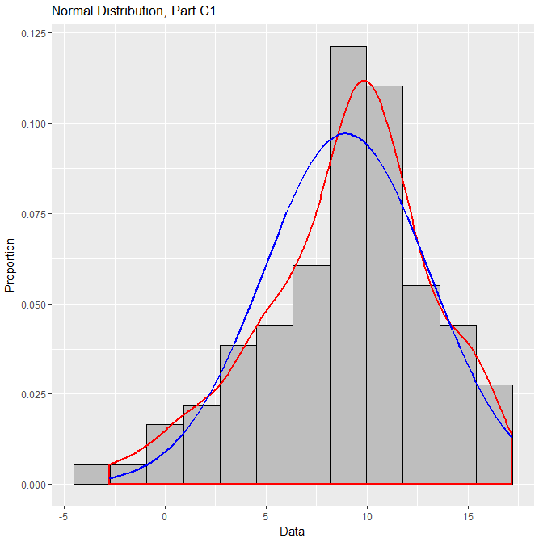

This histogram rather closely resembles a normal density curve. While the general smoothed shape does have a noticeable left skew, it is relatively normal.

**3. Normal Probability Plot**

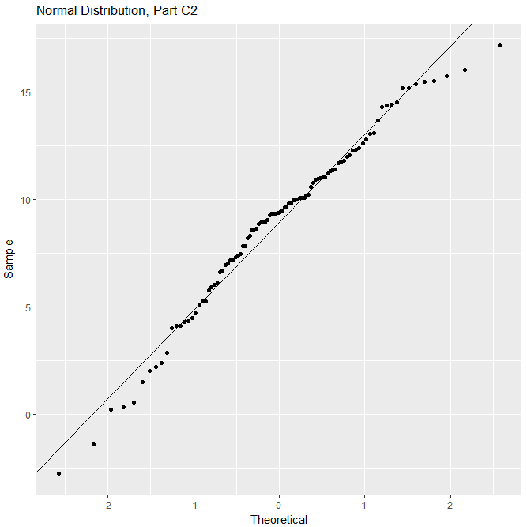

This plot remains relatively close to normality, but there are some significant deviations. Specifically, the leftmost few data points are noticeably below the line of normality, as are the rightmost data points – especially the last one.

**4. Comparison: B and C**

Both the histograms and the normal probability plots demonstrate that the data in Part C far more closely resembles a normal data distribution. This may seem strange, given that Parts B and C are from the same normal distribution; however, because Part C has more data points, the plots much more clearly submit to normality.

**D. Random numbers from other distributions**

**Distribution I: Right Skewed**

**1. Code**

### PART D ###

# generate 100 observations for various distributions, then

# create histograms and normal probability plots

n=100

## (I) right skewed (Exponential) ##

# generate data

Right <- rexp(n,rate=5)

write.table(Right, "Right.txt", sep="\t")

Normal <- Right

title2 <- "Right Skewed Distribution, Part D2"

title3 <- "Right Skewed Distribution, Part D3"

# create histogram

windows()

ggplot(data.frame(Normal=Normal),aes(x=Normal))+

geom_histogram(aes(y=..density..),bins=sqrt(length(Normal))+2,

fill="grey",col="black")+

geom_density(col="red",lwd=1)+

stat_function(fun=dnorm,args=list(mean=mean(Normal),sd=sd(Normal)),

col="blue",lwd=1)+

ggtitle(title2)+

xlab("Data")+

ylab("Proportion")

# create normal probability plot

windows()

ggplot(data.frame(Normal=Normal),aes(sample=Normal))+

stat_qq()+

geom_abline(slope=sd(Normal),intercept=mean(Normal))+

ggtitle(title3)+

xlab("Theoretical")+

ylab("Sample")

**2. Histogram**

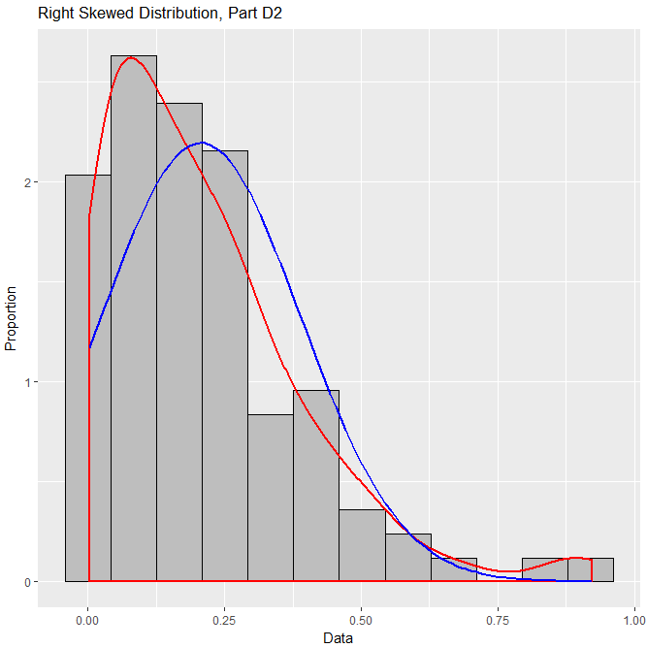

This histogram is indeed clearly right-skewed. Compared to a normal density curve, the left tail is much shorter and the right tail is quite long.

**3. Normal Probability Plot**

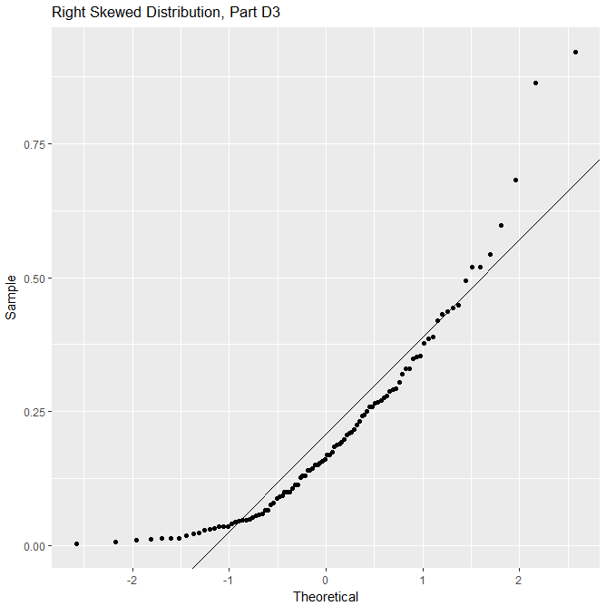

The plot appears to show exponential growth, with the leftmost data markers sitting quite low, climbing higher at an increasing rate as we move right. Observing the deviations from normality, the left and right stand out the most: both are extremely far above the line of normality, with the middle data points slightly below.

**Distribution II: Left Skewed**

**1. Code**

## (II) left skewed (Beta) ##

Left <- rbeta(n,7,0.8)

Normal <- Left

write.table(Left, "Left.txt", sep="\t")

title2 <- "Left Skewed Distribution, Part D2"

title3 <- "Left Skewed Distribution, Part D3"

# create histogram

windows()

ggplot(data.frame(Normal=Normal),aes(x=Normal))+

geom_histogram(aes(y=..density..),bins=sqrt(length(Normal))+2,

fill="grey",col="black")+

geom_density(col="red",lwd=1)+

stat_function(fun=dnorm,args=list(mean=mean(Normal),sd=sd(Normal)),

col="blue",lwd=1)+

ggtitle(title2)+

xlab("Data")+

ylab("Proportion")

# create normal probability plot

windows()

ggplot(data.frame(Normal=Normal),aes(sample=Normal))+

stat_qq()+

geom_abline(slope=sd(Normal),intercept=mean(Normal))+

ggtitle(title3)+

xlab("Theoretical")+

ylab("Sample")

**2. Histogram**

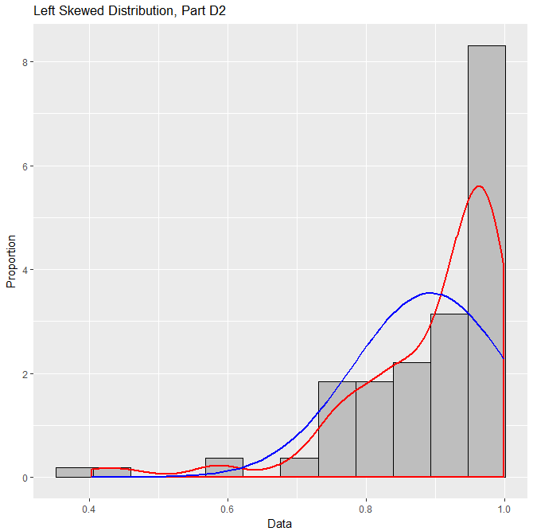

This histogram clearly displays a left-skewed distribution. Compared to a normal density curve, the right tail is quite short and the left tail is very long.

**3. Normal Probability Plot**

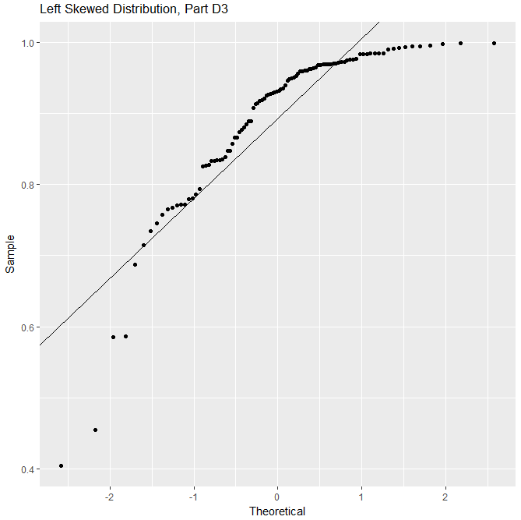

This plot appears to have a vaguely logarithmic shape: the data markers gain height very quickly on the left of the plot and appear to “level out” near 1.0 on the right. Similar to the right-skewed plot, the leftmost and rightmost data points stand out most in terms of deviations from normality; though this time the data points sit far *below* the normal line, with the middle data points slightly above.

**Distribution III: Short Tailed**

**1. Code**

## (III) short tailed (Uniform) ##

Short <- runif(n,min=-3,max=3)

write.table(Short, "Short.txt", sep="\t")

Normal <- Short

title2 <- "Short Tailed Distribution, Part D2"

title3 <- "Short Tailed Distribution, Part D3"

# create histogram

windows()

ggplot(data.frame(Normal=Normal),aes(x=Normal))+

geom_histogram(aes(y=..density..),bins=sqrt(length(Normal))+2,

fill="grey",col="black")+

geom_density(col="red",lwd=1)+

stat_function(fun=dnorm,args=list(mean=mean(Normal),sd=sd(Normal)),

col="blue",lwd=1)+

ggtitle(title2)+

xlab("Data")+

ylab("Proportion")

# create normal probability plot

windows()

ggplot(data.frame(Normal=Normal),aes(sample=Normal))+

stat_qq()+

geom_abline(slope=sd(Normal),intercept=mean(Normal))+

ggtitle(title3)+

xlab("Theoretical")+

ylab("Sample")

**2. Histogram**

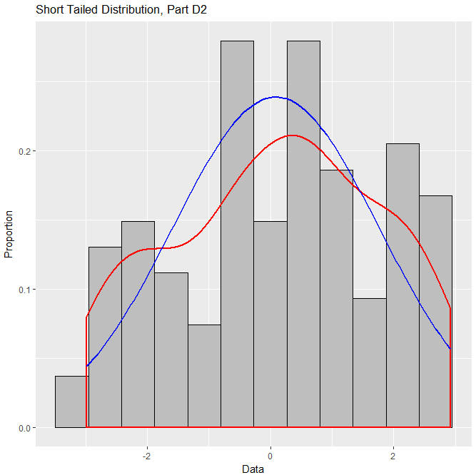

This histogram shows a distribution somewhat similar to normal, but with notably short tails.

**3. Normal Probability Plot**

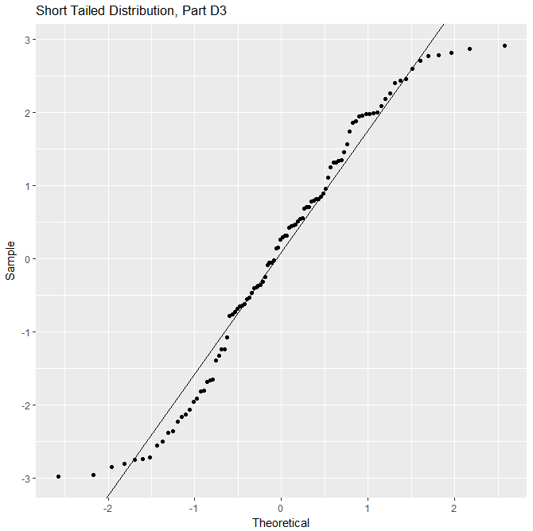

This plot appears to show a vaguely resemble a titration-curve-style shape – that is, the distribution is fairly level on the left and right, with the greatest increase in the center. As far as deviations from normality, the left and right again stand out the most: now with the leftmost data points sitting far above the line of normality and the rightmost far below. It is worth noting that the data appear to “cross” the line of normality at the left, center, and right of the plot.

**Part IV: Long Tailed**

**1. Code**

# (IV) long tailed (t-distribution)

Long <- rt(n,df=1)

write.table(Long, "Long.txt", sep="\t")

Normal <- Long

title2 <- "Long Tailed Distribution, Part D2"

title3 <- "Long Tailed Distribution, Part D3"

# create histogram

windows()

ggplot(data.frame(Normal=Normal),aes(x=Normal))+

geom_histogram(aes(y=..density..),bins=sqrt(length(Normal))+2,

fill="grey",col="black")+

geom_density(col="red",lwd=1)+

stat_function(fun=dnorm,args=list(mean=mean(Normal),sd=sd(Normal)),

col="blue",lwd=1)+

ggtitle(title2)+

xlab("Data")+

ylab("Proportion")

# create normal probability plot

windows()

ggplot(data.frame(Normal=Normal),aes(sample=Normal))+

stat_qq()+

geom_abline(slope=sd(Normal),intercept=mean(Normal))+

ggtitle(title3)+

xlab("Theoretical")+

ylab("Sample")

**2. Histogram**

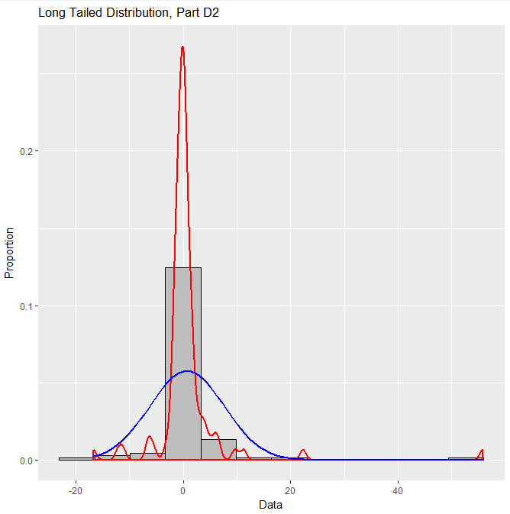

This histogram somewhat resembles a normal distribution, but with extremely long tails, most notably on the right.

**3. Normal Probability Plot**

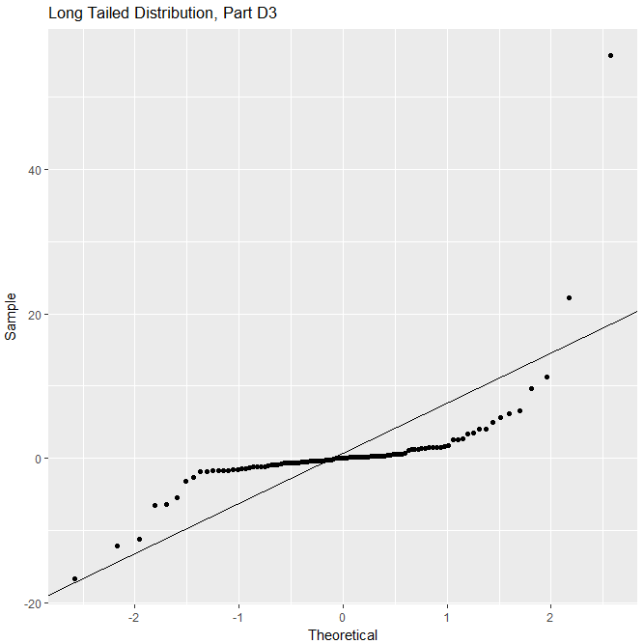

The shape of this plot is a sort of “inverse” of the short tailed normal probability plot – that is, the data points climb quite quickly on the left and right sides of the plot, and appear rather “level” in the center of the plot. The entire shape actually deviates quite significantly from normality, with the left data points sitting above and the right below, except for the rightmost two data points, which sit far above the line of normality.

**F. The distribution of Assaults Per Population**

**1. Code**

### PART F ###

# analyze Number of Assaults per 100,000 people

USData <- read.table("USData_Spring.txt", header=TRUE, sep="\t")

USData_clean <- USData[complete.cases(USData),]

attach(USData_clean)

# create histogram

windows()

ggplot(data.frame(AssaultsPerPopulation=AssaultsPerPopulation), aes(AssaultsPerPopulation))+

geom_histogram(aes(y=..density..),

bins=sqrt(length(AssaultsPerPopulation))+2,

fill="grey",col="black")+

geom_density(col="red",lwd=1)+

stat_function(fun=dnorm,args=list(mean=mean(AssaultsPerPopulation),

sd=sd(AssaultsPerPopulation)),

col="blue",lwd=1)+

ggtitle("Assaults per 100,000 people, Part F2")+

xlab("Data")+

ylab("Proportion")

# create normal probability plot

windows()

ggplot(data.frame(AssaultsPerPopulation=AssaultsPerPopulation),aes(sample=AssaultsPerPopulation))+

stat_qq()+

geom_abline(slope=sd(AssaultsPerPopulation),

intercept=mean(AssaultsPerPopulation))+

ggtitle("Assaults per 100,000 people, Part F3")+

xlab("Theoretical")+

ylab("Sample")

**2. Histogram**

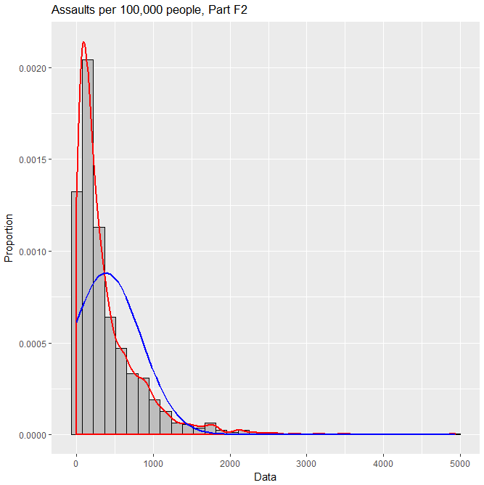

This data appears to have a very strong right-skewed distribution. This is clear from the short left tail and the extremely long right tail.

**3. Normal Probability Plot**

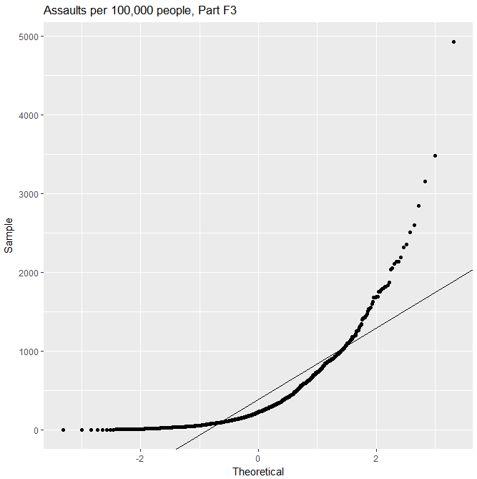

The shape of this plot appears vaguely exponential, which suggests a right-skewed distribution. We can clearly see the data markers beginning rather flat and climbing at an increasing rate as we move right on the plot. We see the left and right data markers are far above the line of normality, with the middle data markets slightly below that line. All of this matches up with what we would see from a right-skewed data distribution.

**APPENDIX. Raw Data**

**Part B**

"x"

"1" 7.16299156485712

"2" 2.02860809676863

"3" 16.62120324901

"4" 15.7894990632249

"5" 13.1569343353345

"6" -0.0392819489880765

"7" 10.9173284238507

"8" 13.538523944467

"9" 14.9040027265487

"10" 10.211184747179

**Part C**

"x"

"1" 11.3608420285513

"2" 6.94898178063054

"3" 7.41867035761383

"4" 2.41703242796681

"5" 8.60857547868209

"6" 8.31287001612322

"7" 7.83036155539504

"8" 7.17649322319547

"9" 14.5452179938871

"10" 9.3388936701564

"11" 6.70234942186502

"12" 11.0360287281982

"13" 9.36891217841827

"14" 5.26486944707355

"15" 8.93457418200799

"16" 0.584681463121802

"17" 11.8019092988723

"18" 9.06243557877412

"19" 2.20716272960254

"20" 12.6082741595531

"21" 7.03450859600393

"22" 9.28938943737717

"23" 10.9520501269473

"24" 4.03982066688201

"25" 15.5317801751328

"26" 11.0291768091307

"27" 10.9895704846459

"28" 9.43293478771573

"29" 9.81168087912775

"30" 0.329342136939516

"31" 10.6049017918153

"32" -2.74882457078672

"33" 8.65084715868642

"34" 2.87830053346952

"35" 13.6758489778809

"36" 7.47270941211789

"37" 5.26863225434863

"38" 9.82061378869824

"39" 17.1925968650868

"40" 11.4225548586764

"41" 11.9943584363114

"42" 12.337668835211

"43" 10.078542540384

"44" 10.2144195077715

"45" 11.2346677276628

"46" 7.84428157959354

"47" 14.3926641341599

"48" 10.9246773053909

"49" 15.5048129095727

"50" 9.67056679163962

"51" 5.10138323743825

"52" 5.91721908758446

"53" 15.1825103160038

"54" 14.4301135807285

"55" 9.49318774282436

"56" 8.56735887447061

"57" 16.0250924612004

"58" 11.7256986692821

"59" 12.283692785371

"60" 10.2225435470395

"61" 6.11275202756562

"62" 15.745837257257

"63" 7.21883227437713

"64" 9.95838572073198

"65" 4.48531232192319

"66" 4.1352263337156

"67" 10.0269333593106

"68" 12.0689994446151

"69" 15.3752871459013

"70" 14.297032298923

"71" 4.33225655505438

"72" 1.53507718204144

"73" 10.0773594414227

"74" 4.73602014870595

"75" 12.8185003450617

"76" 9.64485185565388

"77" 8.9414740107123

"78" 9.97935173686705

"79" 10.7905882390315

"80" 4.36376439998358

"81" -1.38017676208946

"82" 0.221577969856799

"83" 6.62611798431054

"84" 8.88582110679415

"85" 10.073263422197

"86" 11.3188302543467

"87" 5.77479628942466

"88" 2.02415555519344

"89" 8.19967552197945

"90" 9.35848866076982

"91" 13.106908525825

"92" 9.38935168719114

"93" 6.04123891600664

"94" 12.4038489688552

"95" 15.1815827007932

"96" 11.716517734638

"97" 4.15035310477955

"98" 7.34801034491562

"99" 8.93107514992689

"100" 13.0577490689938

**Part D I: Right Skewed**

"x"

"1" 0.0329462281428278

"2" 0.13649770906195

"3" 0.0398461059282371

"4" 0.155942625916543

"5" 0.488146653373666

"6" 0.0165526079013944

"7" 0.0582525201141834

"8" 0.119570961780846

"9" 0.549174616833158

"10" 0.139021913074579

"11" 0.560963465248943

"12" 0.136149619240314

"13" 0.0305924635380507

"14" 0.105056778762098

"15" 0.0852456148713827

"16" 0.0217286430597688

"17" 0.126121812406927

"18" 0.244235698497834

"19" 0.520292589415736

"20" 0.201133471532705

"21" 0.120274490118027

"22" 0.0639994025230408

"23" 0.81373987603457

"24" 0.164187490931692

"25" 0.0623068482615054

"26" 0.12722976738587

"27" 0.36568713596273

"28" 0.274279042138698

"29" 0.0239566188477344

"30" 0.090001658629626

"31" 0.0511474202387035

"32" 0.0954259978607297

"33" 0.122913331817836

"34" 0.100898827984929

"35" 0.00846930214821731

"36" 0.0307860342785716

"37" 0.580111809041271

"38" 0.235053297123852

"39" 0.428225597341485

"40" 0.170673947474225

"41" 0.275547936364057

"42" 0.429603602094344

"43" 0.0108297001703708

"44" 0.250512296106749

"45" 0.351198980940466

"46" 0.284059054387693

"47" 0.46451516409678

"48" 0.076015699096024

"49" 0.488610116484065

"50" 0.0952877105213702

"51" 0.240883264309707

"52" 0.217917389414253

"53" 0.0991169169545174

"54" 0.292677654075321

"55" 0.0397429691627622

"56" 0.199793926618042

"57" 0.106959379091859

"58" 0.281903938804225

"59" 0.132995110377669

"60" 0.075664896145463

"61" 0.0255660917113194

"62" 0.182754581806988

"63" 0.0297642929881743

"64" 0.414037320746069

"65" 0.127583301626146

"66" 0.48241586303524

"67" 0.0694363433867693

"68" 0.133583655953407

"69" 0.386162503419404

"70" 0.1414972922917

"71" 0.0481046048078002

"72" 0.0100186483003199

"73" 0.0579731003381312

"74" 0.217531021748354

"75" 0.0199325659046572

"76" 0.0382066253572702

"77" 0.0899240291677415

"78" 0.0104941795580089

"79" 0.476560968507953

"80" 0.0947228825651109

"81" 0.118110656470902

"82" 0.137732434645295

"83" 0.116921068076044

"84" 0.0585557450540364

"85" 0.121665097307414

"86" 0.028361501917243

"87" 0.19117311964834

"88" 0.135816537123173

"89" 0.143609825513306

"90" 0.164460483034692

"91" 0.385327581299429

"92" 0.0717680975985355

"93" 0.0617601628971032

"94" 0.201020165013377

"95" 0.13954757097877

"96" 0.052945371744183

"97" 0.0383689853362739

"98" 0.109596757311374

"99" 0.334604750556831

"100" 0.213367550439181

**Part D II: Left Skewed**

"x"

"1" 0.977472547227301

"2" 0.987405597675125

"3" 0.871976893369907

"4" 0.991930847817831

"5" 0.8139317832128

"6" 0.99991431087755

"7" 0.989650843515454

"8" 0.951796413323863

"9" 0.964405541477698

"10" 0.851018647720818

"11" 0.857078645953627

"12" 0.991469048332612

"13" 0.772890827721601

"14" 0.767368797258918

"15" 0.919389351600152

"16" 0.90716785368485

"17" 0.841590026184307

"18" 0.973852985566496

"19" 0.862620321431305

"20" 0.82683360214179

"21" 0.843682202621014

"22" 0.829483616911871

"23" 0.896616023053439

"24" 0.984051974804798

"25" 0.906252666456918

"26" 0.599312134558197

"27" 0.859740816915793

"28" 0.77056052294257

"29" 0.998934453672656

"30" 0.841759308964578

"31" 0.861259577180465

"32" 0.602160351834443

"33" 0.866640730969

"34" 0.985848330358716

"35" 0.938889844565632

"36" 0.867114838442874

"37" 0.996893466782782

"38" 0.600024416127271

"39" 0.985385269529805

"40" 0.946540564086833

"41" 0.86901419798136

"42" 0.999196925972523

"43" 0.986861486364014

"44" 0.691616401703313

"45" 0.867968929633481

"46" 0.800794453716627

"47" 0.915548413015086

"48" 0.937793350511841

"49" 0.9976757878889

"50" 0.973659851671472

"51" 0.994975932845694

"52" 0.854993696402886

"53" 0.967085225725844

"54" 0.923478171801705

"55" 0.92852397347476

"56" 0.956380170532321

"57" 0.964552016754239

"58" 0.888657514062147

"59" 0.991748394867237

"60" 0.953573075005917

"61" 0.839195519002213

"62" 0.912244935808166

"63" 0.966537791010896

"64" 0.979759634625135

"65" 0.796833523626721

"66" 0.837989791242644

"67" 0.994755917656343

"68" 0.990190566653225

"69" 0.976578021192617

"70" 0.95618984476118

"71" 0.928914593368122

"72" 0.91384436581876

"73" 0.910971401839094

"74" 0.891426776315314

"75" 0.970060470835474

"76" 0.886209065654654

"77" 0.992721681654692

"78" 0.987128326108576

"79" 0.927961063822617

"80" 0.926946580924547

"81" 0.921930998439441

"82" 0.764215333811808

"83" 0.675707010734439

"84" 0.986309047842646

"85" 0.795653640637342

"86" 0.989347518467252

"87" 0.995422996010289

"88" 0.885268789254993

"89" 0.956464132669117

"90" 0.815190683138323

"91" 0.993256306553423

"92" 0.998712022209234

"93" 0.799478911931629

"94" 0.666768101517251

"95" 0.900347277979047

"96" 0.703551009213491

"97" 0.828398128648274

"98" 0.907922184381701

"99" 0.970499538785644

"100" 0.830364980492476

**Part D III: Short Tailed**

"x"

"1" 2.58746579708531

"2" 2.07391649717465

"3" -0.401598220691085

"4" 0.304720661602914

"5" -1.44850478880107

"6" -0.26636288780719

"7" -1.75655236607417

"8" -2.19529654551297

"9" 2.29005573503673

"10" 0.884771027136594

"11" 0.880886496976018

"12" 2.65778948832303

"13" 1.13507711794227

"14" -2.84168748417869

"15" -0.680308157578111

"16" 0.463834832422435

"17" 1.08866210142151

"18" 1.47647474426776

"19" -2.0360864396207

"20" -0.124292965047061

"21" 1.38593446137384

"22" -2.27516025211662

"23" 2.6116881868802

"24" -0.76673419168219

"25" 2.39345729118213

"26" 1.80414729192853

"27" 0.255126643460244

"28" -0.0691120843403041

"29" 1.61075538536534

"30" 0.405358605086803

"31" -0.0536438282579184

"32" 1.39819407602772

"33" -2.70010149618611

"34" 0.241749918088317

"35" 1.69175785174593

"36" -2.88681181054562

"37" 0.638613177929074

"38" 0.986545308027416

"39" 0.0394530245102942

"40" -2.52019882528111

"41" -1.57964417198673

"42" 1.6073120185174

"43" 2.9457683279179

"44" -0.81462882226333

"45" 0.949457088019699

"46" -0.446520638186485

"47" 1.60312855895609

"48" -1.93944857502356

"49" 1.52491811988875

"50" -2.85907074809074

"51" 2.62531822035089

"52" -0.932122666854411

"53" -0.154677574988455

"54" 2.88206314807758

"55" -0.672739170491695

"56" -0.574384379200637

"57" -1.83897601487115

"58" 1.47597938217223

"59" 0.557128134649247

"60" -2.11177759012207

"61" -1.1623805584386

"62" 0.708426031284034

"63" 1.91926929121837

"64" 0.0915038846433163

"65" 1.3187703313306

"66" -0.747216625604779

"67" 0.346440654247999

"68" 0.632062064018101

"69" 0.949839807115495

"70" 1.21298344340175

"71" 0.0116188223473728

"72" -0.504507774487138

"73" 2.69957247935236

"74" -2.1220094463788

"75" 1.37845164304599

"76" 0.873166338074952

"77" -1.40964363422245

"78" -2.8500639712438

"79" 1.247082979884

"80" -2.94007635070011

"81" 2.06885933456942

"82" -2.85186778195202

"83" 1.40935650933534

"84" 1.49648291571066

"85" -0.539759958162904

"86" -0.365986045449972

"87" 2.64316763961688

"88" 2.49743884848431

"89" 0.398766189347953

"90" 2.95668476633728

"91" 1.21128969127312

"92" 0.32365145534277

"93" -0.347219405695796

"94" 0.946325579658151

"95" 0.871117161121219

"96" 1.68887313036248

"97" -2.97139551630244

"98" -1.29834165237844

"99" 2.35851217992604

"100" 1.5087335226126

**Part D IV: Long Tailed**

"x"

"1" -0.325680534680333

"2" -0.576847434043157

"3" 0.890484803157837

"4" 13.0611553028325

"5" 0.524285055090195

"6" -0.499629078469114

"7" 1.85479284641873

"8" 1.68084429782836

"9" -1.74241246391235

"10" 0.268317594221744

"11" -0.04232046213455

"12" 1.07323344675946

"13" 0.291909460335999

"14" -1.09908097315725

"15" -1.51234831519094

"16" 1.53344764965504

"17" 0.563938088624327

"18" -0.89532324270412

"19" 0.573285140513458

"20" 0.246711262616197

"21" -2.07209176794214

"22" -0.25253569893964

"23" -0.681860825848499

"24" -0.993348796032041

"25" 0.399517324863114

"26" -4.03083422378489

"27" 11.7863284589786

"28" -1.04153442116242

"29" 0.335647064971255

"30" 3.09542062510906

"31" 2.84809001168715

"32" -0.678275625245869

"33" -6.12654727736761

"34" -2.35083356526194

"35" 0.268514726467994

"36" -1.92827506386398

"37" -0.297448640365298

"38" 3.4422926480057

"39" 0.337072509279367

"40" -5.33827846788897

"41" 9.16290913614364

"42" -1.19332896645698

"43" 2.52498456729642

"44" 0.243964743940408

"45" 3.42844929182602

"46" 0.389442703024154

"47" 8.63959551399858

"48" 5.914250401502

"49" -1.80045885726437

"50" -1.66087244724402

"51" 0.0472743242528888

"52" 6.663096075572

"53" -6.1189474369159

"54" 0.748160934284106

"55" -0.756118749370448

"56" -0.209584806554246

"57" -0.0395925774400547

"58" 1.47705775007449

"59" -1.08463703005634

"60" 0.433509444569659

"61" 0.0451620519196237

"62" -0.576196914544836

"63" -0.726872512519585

"64" -0.595884958885816

"65" -0.363479176539447

"66" -4.5133668639195

"67" 3.80310043374009

"68" 1.84353283995908

"69" 0.337215222829993

"70" 1.20435478825247

"71" 0.529256899127296

"72" 1.49380155010274

"73" -0.36873792400824

"74" 2.60043044337548

"75" 1.31132346820114

"76" -0.21597981172851

"77" 0.500262641016494

"78" 3.1994514442941

"79" 0.525291703670761

"80" 0.851536111295402

"81" 0.0719719581629776

"82" -0.429068743419395

"83" 0.469894216698261

"84" 2.44582203773195

"85" -1.32764305029016

"86" -0.368857278397946

"87" 0.667828711678466

"88" -0.287960089794913

"89" 0.077945252979601

"90" 0.699069179055226

"91" -2.59001597896677

"92" -1.91403535625291

"93" -1.30675274667084

"94" 2.62858019302545

"95" 2.75555771967254

"96" 0.990865933939102

"97" -0.452047712942472

"98" 1.02315266637424

"99" 0.165761929429283

"100" 1.73086655568882